Federation

Introduction:
Identity federation is a mechanism that allows authentication across different enterprises in different trust domains based on a trust factor. This makes access easy, as users do not have to remember a different set of credentials for every application they use.

In this tutorial, we are going to see how to enable federated authentication with WSO2 Identity Server. Here we have used Google as the federated authenticator and a sample web application called pickup-dispatch for demonstration.

After successfully configuring Google as a federated authenticator, users will be able to authenticate by google credentials.

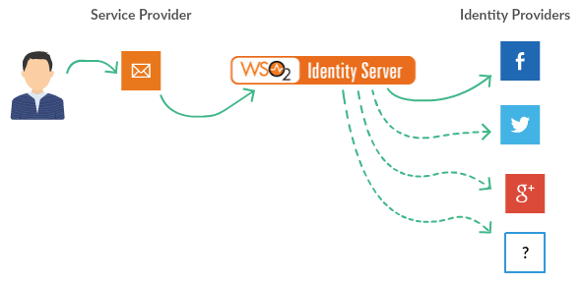

Setting up:

Configure Google Client Application
- Go to Google API Console and navigate to the Credentials tab from the sidebar.
- If you have not created a Project, create one using the option shown in the screen.
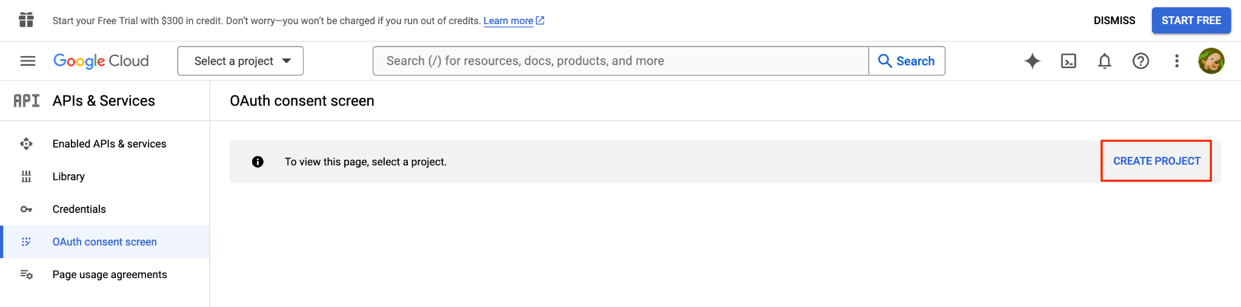

- Setup a consent screen if you have not already created one.
  - In the left nav, open APIs & Services → OAuth consent screen. In the current console this lands you on Google Auth Platform; if the project has never been configured, you'll see a Get started button.
  - App information - enter an App name (this is the name your users see on the Google consent page, so use something recognisable like your company or app name) and pick a User support email from the dropdown.
  - Audience - choose External.
    - External - any Google account can sign in. This is what you want unless every user is in your own Google Workspace.
    - Internal - only accounts in your Workspace org; the option is greyed out if the project isn't under a Workspace.
  - Contact information - enter a developer email address. Google uses it for change notifications only.
  - Accept the Google API Services User Data Policy and click Create.
- Then configure an OAuth web application in Google by selecting OAuth Client ID from the Create Credentials dropdown.
  - Select Web application as the application type and give a name for the application (eg: PickupDispatch).
  - Enter the Authorized redirect URI as https://localhost:9443/commonauth (This is the endpoint in WSO2 Identity Server which accepts the response sent by Google).
  - Once the application client is created successfully, you will get the client ID and the client secret in a pop up screen.
    - Client-id: 913851368910-rood732buqpiq34guclrab3uq56pi2ar.apps.googleusercontent.com
    - Client-secret: 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

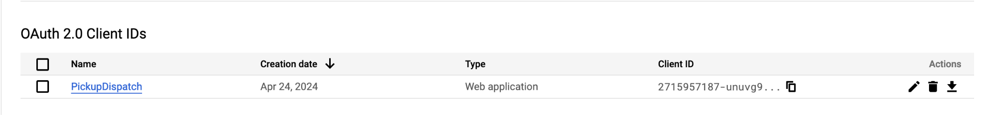

Configure Google IdP in WSO2 IS
- Login to the WSO2 Identity Server Console, using your admin credentials (e.g. admin:admin).
- In the WSO2 Identity Server Console, from the menu click Connections.
- Click + New Connection.
- From the available templates select Google template.
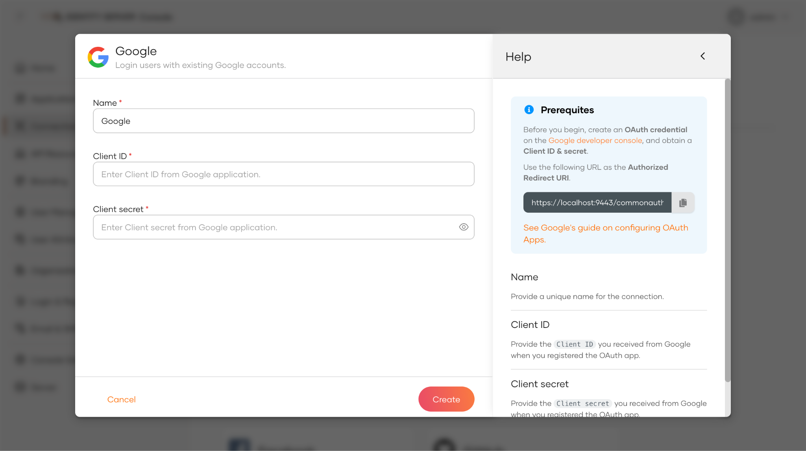
- Add the noted Client ID and Client Secret extracted in Configure Google Client Application step 6 in the respective fields.
- Click Create.

Configure Login Flow in Sample Application

- Use the Dispatch Application configured in 5. Single Sign-On with OpenID Connect Lab.
- In the WSO2 Identity Server Console, from the menu click Applications.
- Click on application Dispatch.
- Goto the Login Flow.
- In the displayed mobile view click on the + Add Sign In Option.
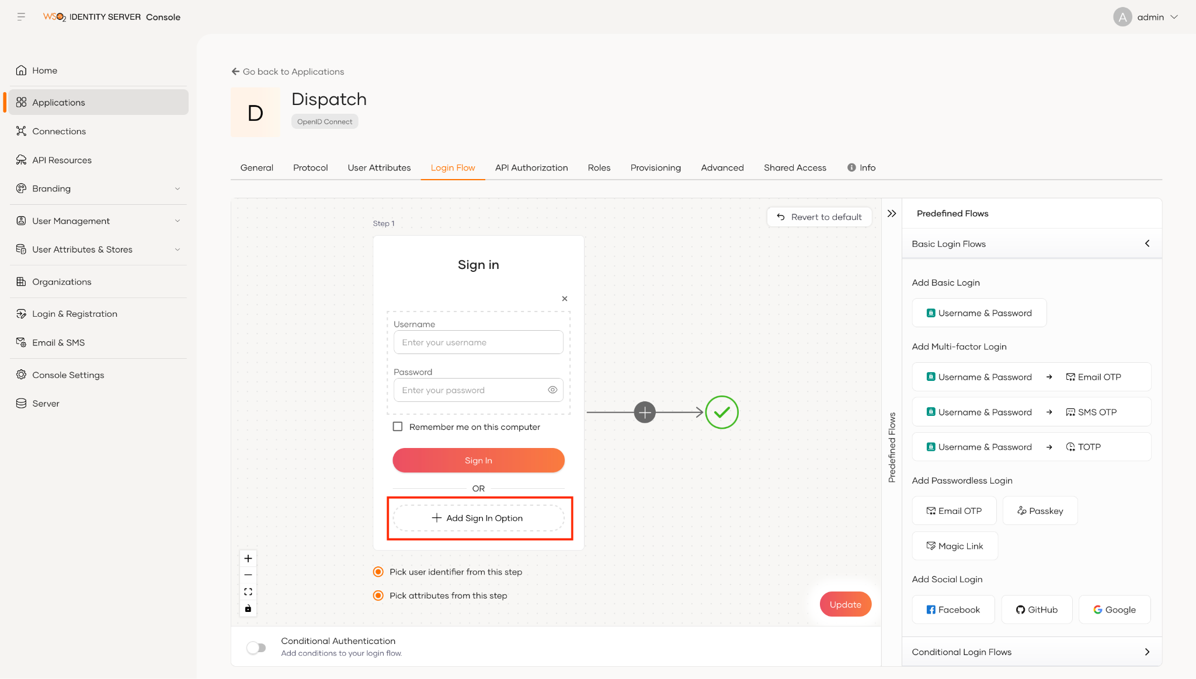
- Scroll down a bit in the listed Authentication options.
- Select Google and click Add.
- Click Update.

Try It:

- Open an Incognito Browser Window.
- Access the link http://localhost:8080/pickup-dispatch and click on the LOGIN button.
- You will be redirected to the Google Sign in page.
- Provide the valid email credentials.
- After providing the approval to view all the user information by clicking on the consent page, you will be logged into the Dispatch application.

